THE MUNICIPALITIES OF DAUGAVPILS AND ANYKŠČIAI INVITE TO FIND OUT THE NATURE VALUES FOUND IN URBAN WETLANDS

Daugavpils City Council in cooperation with the Municipal Administration of the Anykščiai Region in 2020 launched a joint Interreg V-A Latvia – Lithuania Programme 2014-2020 (www.latlit.eu) project No. LLI – 472 "Joint Management of Urban Wetland Areas in border region Latvia-Lithuania" (Urb-Area). The aim of the project is to develop a new and effective approach to joint cross-border management of urban wetlands.

In order to raise environmental awareness and understanding of the need to preserve wetlands among residents and visitors of Daugavpils and Anykščiai, various public education activities have been implemented within the project. In the framework of the project an on-line application https://urbanwetland.eu/ has been developed, it provides an electronic catalogue of the most important species and biotopes of the Esplanade Wetland in Daugavpils and the Green Pond in Anykščiai. The descriptions of the species and biotopes included in the electronic catalogue are available in Latvian, Lithuanian, English and Russian. The eco-education materials section of the application include various educational games.

In the "Observations" section of the application, visitors of the Esplanade Wetland in Daugavpils and the Green Pond in Anykščiai can upload photos of their observations of the wetlands. After new observations are registered in the system, the information is sent to the experts involved in the project, who identify the species detected and publish the observations in the application.
Within the project, online cameras have been installed in the Esplanade Wetland in Daugavpils and the Green Pond in Anykščiai, which can be connected and live-streamed via the application. The specific locations of the cameras in the wetlands were selected in cooperation with the experts involved in the project. The cameras are placed on specially designed pontoons and operate autonomously. The energy needed to operate the cameras is generated by a solar panel. The solutions chosen for the project minimise potential disturbance to the nesting bird populations in the area, as the cameras do not require regular online maintenance.

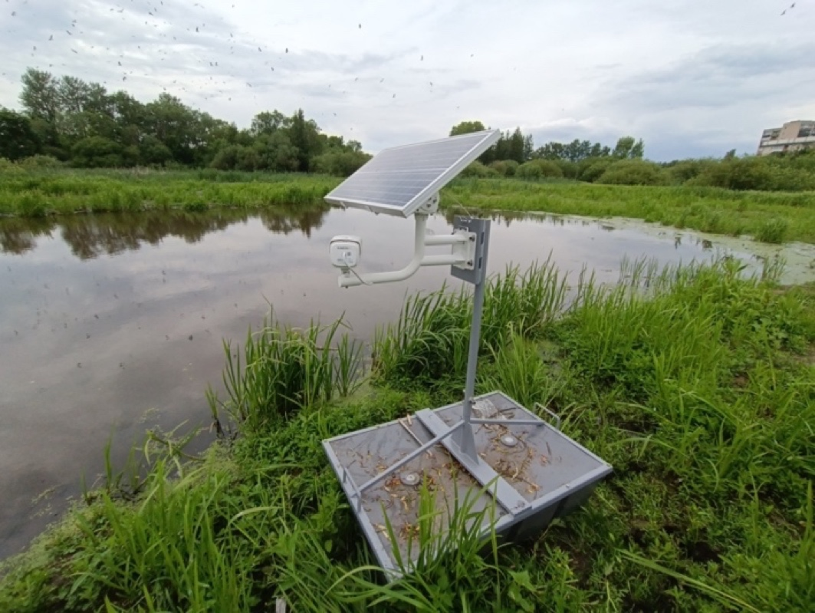 |  | 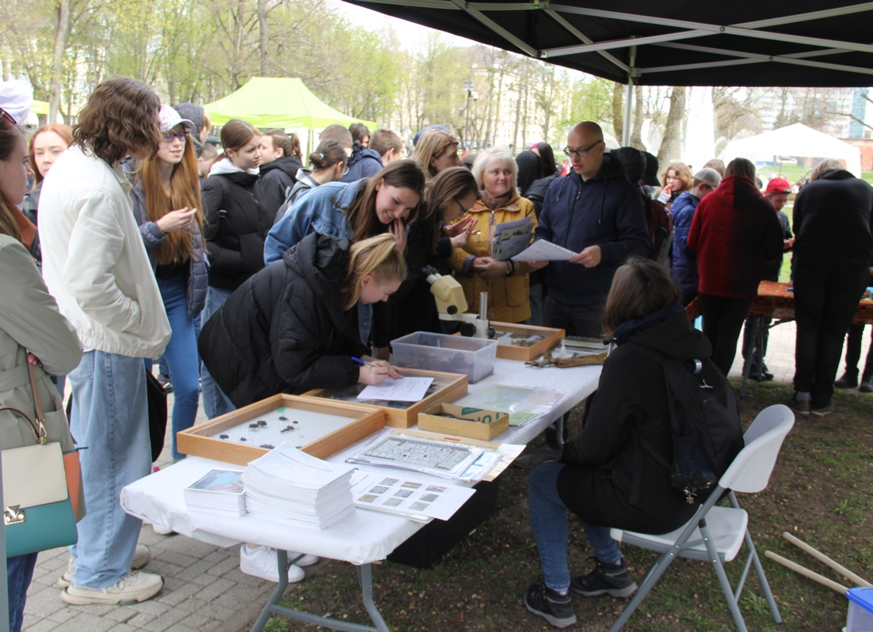
Esplanādes mitrāja izvietotā tiešsaistes kamera Esplanade Wetland Online Camera  (Photo: U. Valainis) | Vides dienas Daugavpilī ietvaros organizētā nodarbība par Esplanādes mitrāju Lesson on Esplanade wetland organised within the framework of the Environment Day in Daugavpils (Photo: D. Krasnopoļska)

During the Environment Day in Daugavpils on 5 May, 2022, the nature experts involved in the project organised educational activities for different target audiences. The participants were from different age groups and interests - preschool children and schoolchildren of different ages, students and environmental specialists. The content of the activities was adapted to the specificities of each target audience. Similar educational activities will be organised in September in Anykščiai.

The nature and environment experts involved in the project developed methodological materials for ecological education on wetlands for different age groups. The methodological materials developed by the experts can be used after the end of the project in various environmental education activities to raise awareness about the need and importance of wetland conservation. Within the project, binoculars and aquascopes have been purchased for the Latgale Zoo and will be used to organise environmental education activities.

Project title: “Joint Management of Urban Wetland Areas in border region Latvia-Lithuania”
Project acronym: Urb-Area
Project number: LLI – 472
ERDF funding: 319 719.36 EUR
More about the project:
https://www.daugavpils.lv/en/city/development-of-the-city/international-projects/urb-area

The contents are the sole responsibility of Daugavpils City Municipality and can under no circumstances be regarded as reflecting the position of the European Union.

Additional information:
Head of Management Plan development
Dr. biol. Uldis Valainis
phone: 26113065
e-mail: uldis.valainis@biology.lv

